Praktikum 5
Routing Campuran (EIGRP + Static)

No | Keterangan
1 | Buatlah Topologi dengan Packet Tracer sebagai berikut
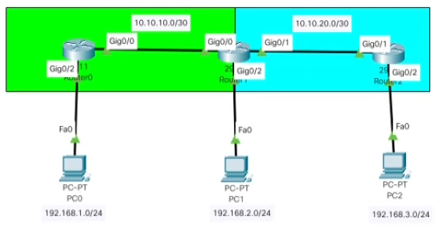
2 | Berikan IP kepada Router 2911 dan PC sebagai berikut
Router0:
GigabitEthernet0/0 - 10.10.10.1 255.255.255.252
GigabitEthernet0/2 - 192.168.1.1 255.255.255.0 - Gateway

Router1:
GigabitEthernet0/0 - 10.10.10.2 255.255.255.252
GigabitEthernet0/1 - 10.10.20.1 255.255.255.252
GigabitEthernet0/2 - 192.168.2.1 255.255.255.0 - Gateway

Router2:
GigabitEthernet0/1 - 10.10.20.2 255.255.255.252
GigabitEthernet0/2 - 192.168.3.1 255.255.255.0 - Gateway

PC0 : 192.168.1.2 255.255.255.0, GW: 192.168.1.1
PC1 : 192.168.2.2 255.255.255.0, GW: 192.168.2.1
PC2 : 192.168.3.2 255.255.255.0, GW: 192.168.3.1
3 | Konfigurasikan EIGRP Routing
Router0:
Router#config t
Router(config)#router eigrp 25
Router(config-router)#no auto
Router(config-router)#net 10.10.10.0
Router(config-router)#net 192.168.1.0
Router(config-router)#

Router1:
Router#config t
Enter configuration commands, one per line. End with CNTL/Z.
Router(config)#router eigrp 25
Router(config-router)#no auto
Router(config-router)#net 10.10.20.0
Router(config-router)#net 192.168.2.0
4 | Konfigurasikan Static Routing
Router1:
ip route 192.168.3.0 255.255.255.0 10.10.20.2

Router2:
Router#config t
Enter configuration commands, one per line. End with CNTL/Z.
Router(config)#ip route 192.168.1.0 255.255.255.0 10.10.20.1
Router(config)#ip route 192.168.2.0 255.255.255.0 10.10.20.1
Router(config)#ip route 10.10.10.0 255.255.255.0 10.10.20.1
5 | Konfigurasikan Redistribute di Router Tengah (Antara EIGRP dan Static)
Router1:
Router(config)#router eigrp 25
Router(config-router)#redistri
Router(config-router)#redistribute static
4 | Cek Router Untuk Keberhasilan Routing, show ip route. Contoh: Router0
Router0:
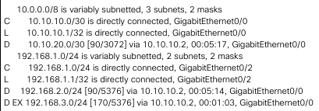
Router1:
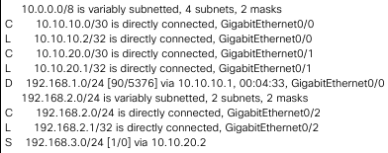
Router2:
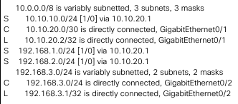
5 | Tes PING dari Ujung ke Ujung, dan Pastikan Sukses
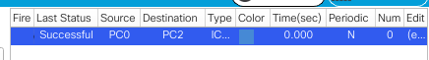
6 | Selesai

